Perplexity in Machine Learning (NLP)
Perplexity (PPL) is a metric used to evaluate language models. It measures how well a model predicts a sequence of words.
- Lower perplexity → Better model performance (more confident predictions).
- Higher perplexity → Worse model performance (more uncertain predictions).

🔥 1. Perplexity Formula

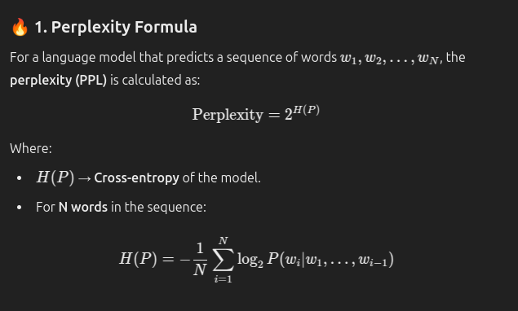

🚀 2. Intuitive Interpretation
- Perplexity measures how "confused" or "uncertain" the model is when making predictions.
- If a model has a perplexity of 10, it means the model is as uncertain as randomly picking from 10 possible words.
✅ Example:
- Perplexity = 1 → Perfect model (no confusion, predicts every word correctly).
- Perplexity = 1000 → Poor model (random guesses among 1000 possible words).

⚡ 3. Real-World Example
If a language model is predicting the next word in the sentence:
"The cat is sitting on the _____"
- The model assigns probabilities to possible next words:
- "mat" → 0.7
- "table" → 0.2
- "roof" → 0.05
- "sky" → 0.05
- If the true word is "mat", a low perplexity score indicates the model correctly assigns a high probability to the right word.
- A higher perplexity score indicates the model is uncertain or incorrect.

🎯 4. Perplexity and Model Quality
- Lower PPL → Better language model (accurate predictions).
- Higher PPL → Poorer performance (more uncertainty).
- Perplexity benchmarks:
- GPT-2: PPL ≈ 20–40 on English text.
- GPT-3: PPL ≈ 15–20 (better predictions).
- LLaMA-2: PPL ≈ 10–15 (more refined predictions).

✅ Key Takeaway
- Perplexity → Measures how well a language model predicts text.
- Low perplexity → Model is confident and accurate.
- High perplexity → Model is uncertain or inaccurate.
- Used to evaluate and compare the quality of NLP models. 🚀

